By

*Kesini Kandasamy*

Assignment 4.1: CNN Vs Transformers

Contents

Assignment Instructions 2

Assignment & Solutions 3

Task 1: Utilise Libraries/Dataset 3

Task 2: Generate at least two EDA visualisations 3

Task 3: Analyse data quality 5

Task 4: Construct a CNN Model 5

Task 5: Train the CNN model using the CIFAR-10 dataset 5

Task 6: Display model architecture and training progress 7

Task 7: Construct a ViT model 8

Task 8: Train the ViT model using the CIFAR-10 dataset 12

Task 9: Display model architecture and training progress 14

Task 10: Compare training and validation results for each model: 18

|  |  |
| --- | --- |
| Assignment 4.1  CNNs Vs. Transformers |  |

# Assignment Instructions

#### **Assignment Instructions:**

Develop and compare CNN and Transformer models for image classification to understand the strengths, weaknesses, and appropriate applications of each architecture. This assignment will help you build practical experience with modern deep learning architectures and their implementation.

Create a Python notebook to implement, train, and evaluate these two neural network architectures utilising the CIFAR-10 dataset.

Refer to the code from the following link and modify it as required before integrating it within your Jupyter Notebook to import the CIFAR-10 dataset - <https://colab.research.google.com/github/keras-team/keras-io/blob/master/examples/vision/ipynb/image_classification_with_vision_transformer.ipynb>

#### **Dataset**

* The CIFAR-10 dataset consists of 60,000 32x32 color images in 10 classes, with 6,000 images per class. The dataset is divided into 50,000 training images and 10,000 testing images. The classes are:
  + Airplane
  + Automobile
  + Bird
  + Cat
  + Deer
  + Dog
  + Frog
  + Horse
  + Ship
  + TruckOutcome: Class variable (0 or 1) indicating whether the patient has diabetes (1) or not (0)

# Assignment & Solutions

## Task 1: Utilise Libraries/Dataset

* Import the necessary libraries (TensorFlow/Keras, NumPy, Matplotlib, etc.)
* Load and explore the CIFAR-10 dataset

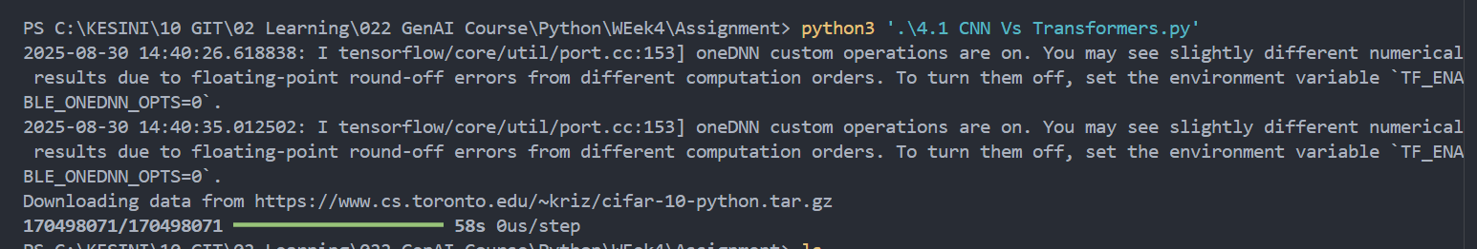

## Task 2: Generate at least two EDA visualisations

* Generate at least two EDA visualisations (class distribution and sample images)

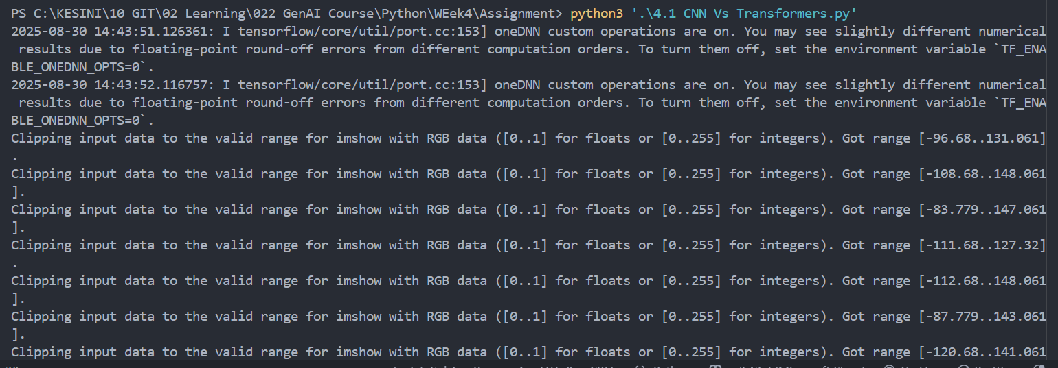

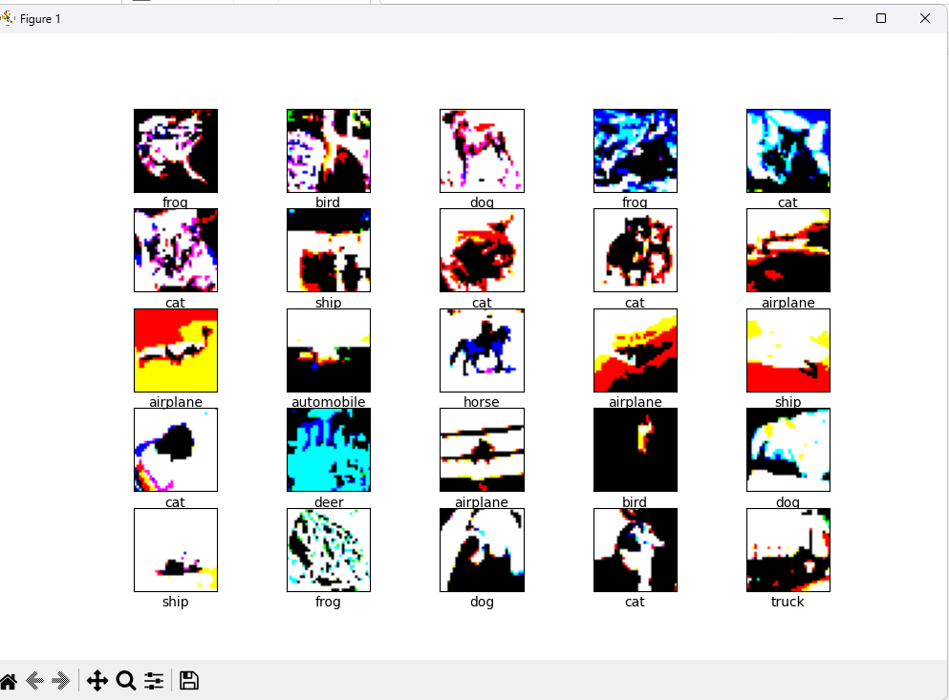

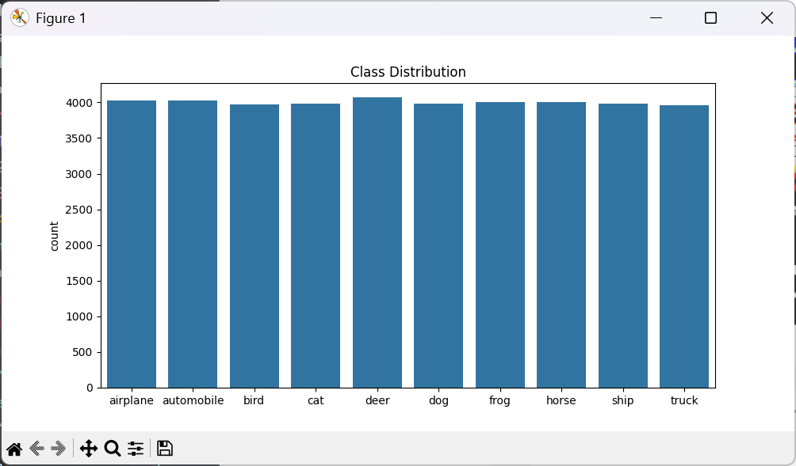

## Task 3: Analyse data quality

* Check for missing values or outliers and data quality issues

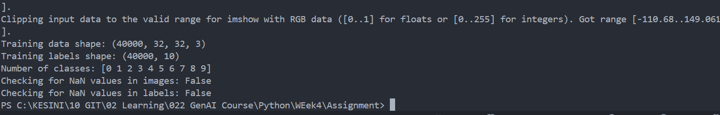

## Task 4: Construct a CNN Model

* Construct a CNN model with appropriate layers (convolutional, pooling, fully connected)

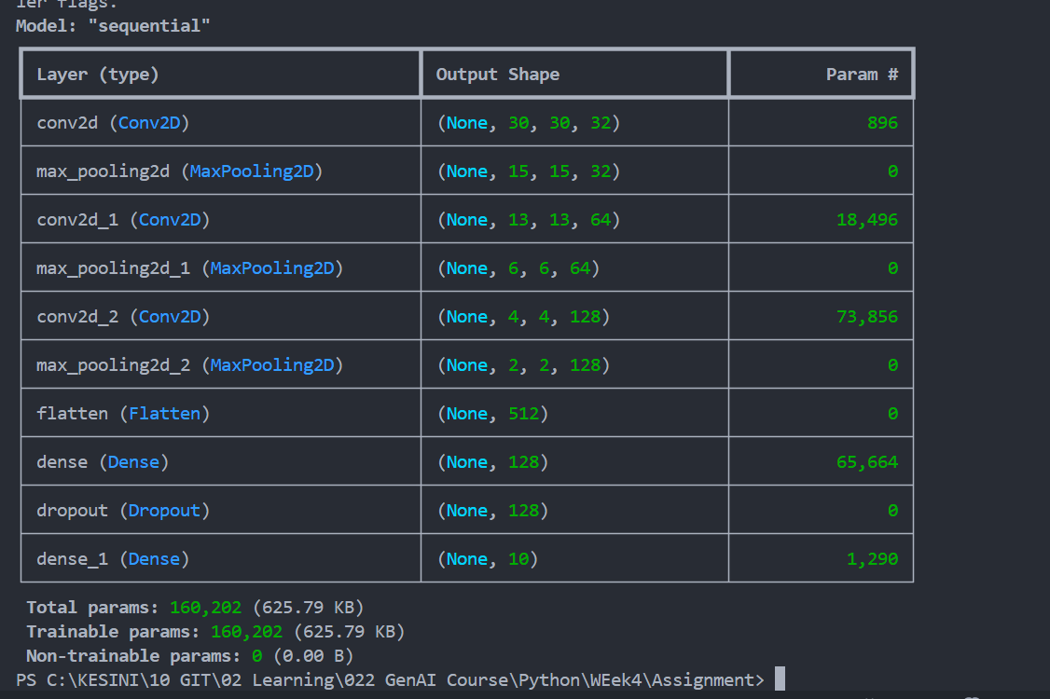

## Task 5: Train the CNN model using the CIFAR-10 dataset

* Train the model using the training dataset with an appropriate number of training epochs

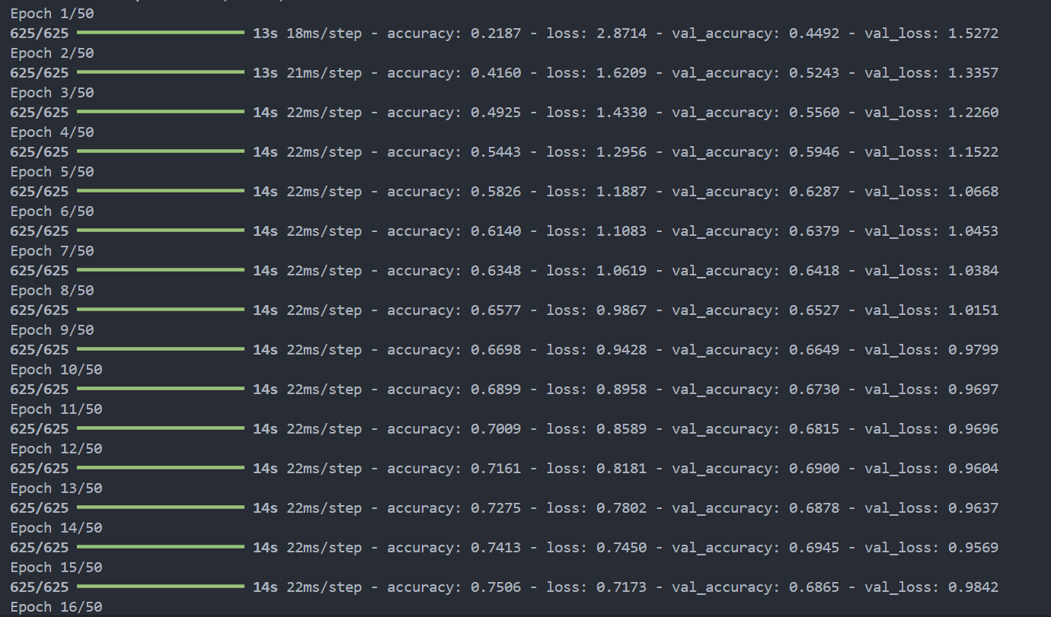

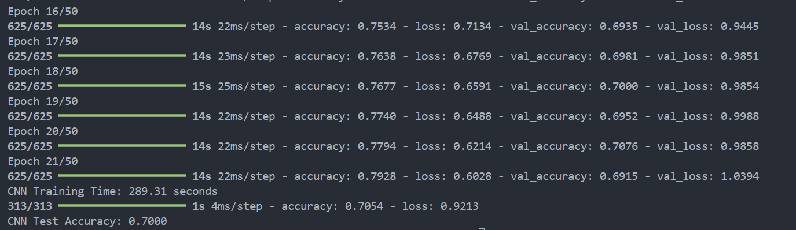

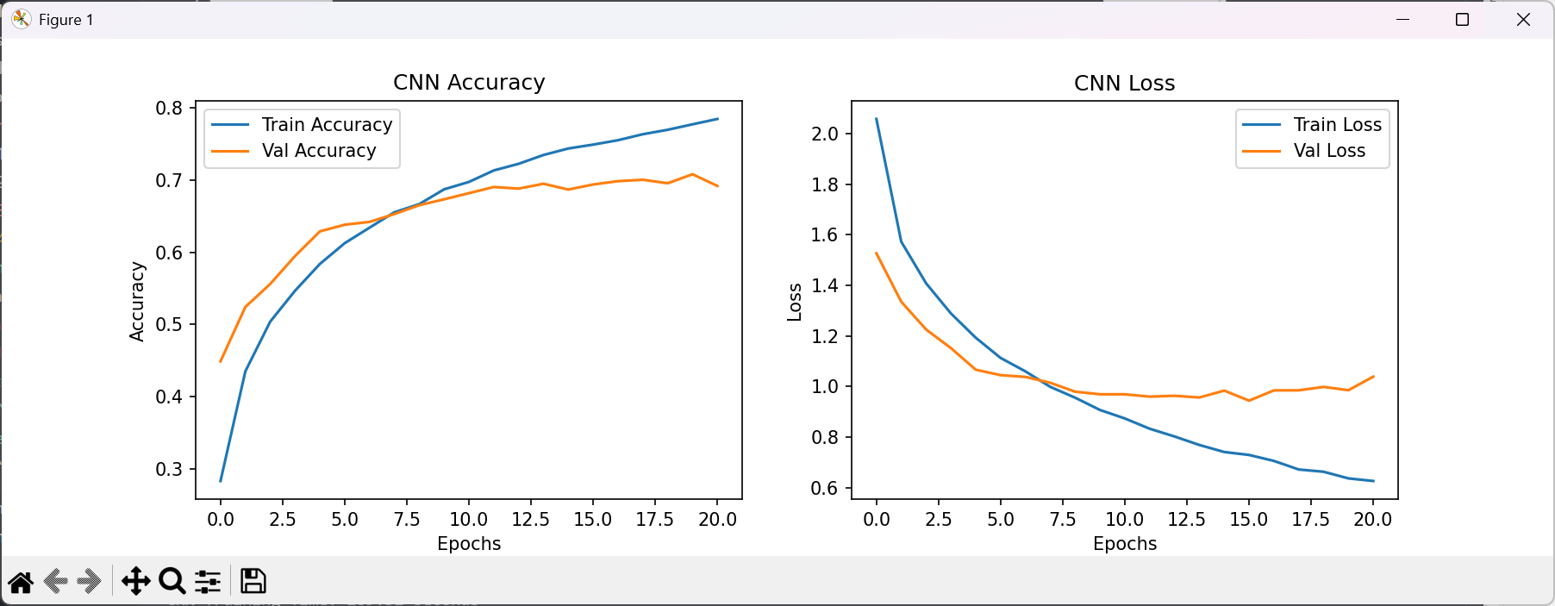

## Task 6: Display model architecture and training progress

* Display the model architecture and training progress

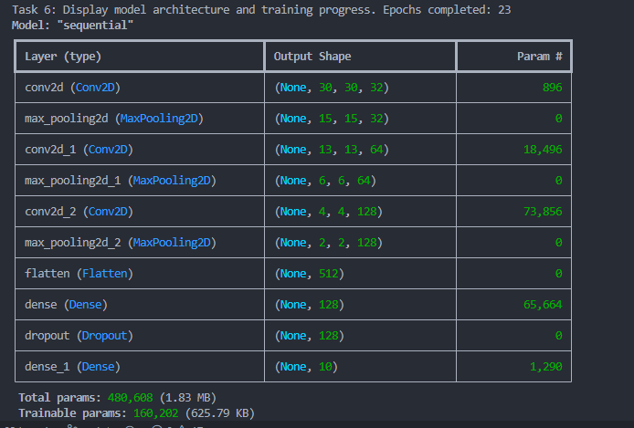

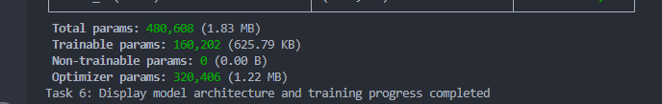

## Task 7: Construct a ViT model

* Implement a Vision Transformer (ViT) model with attention mechanisms

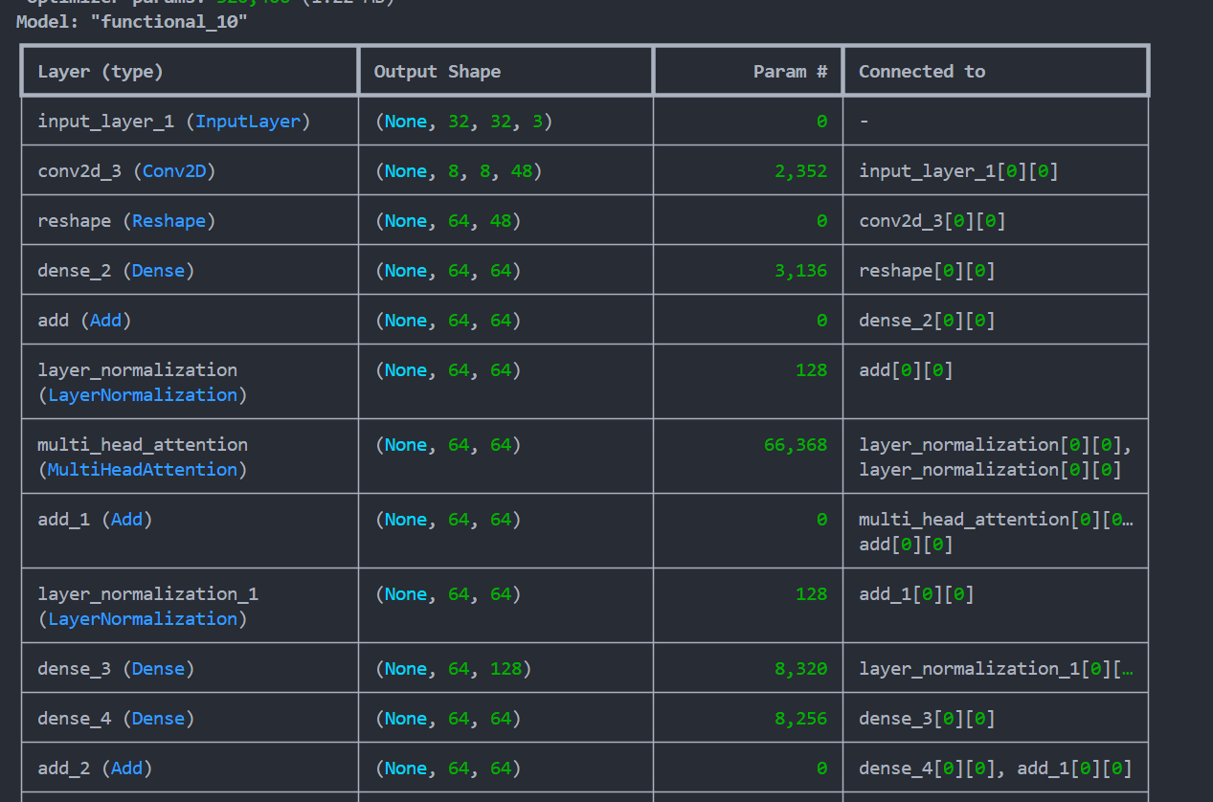

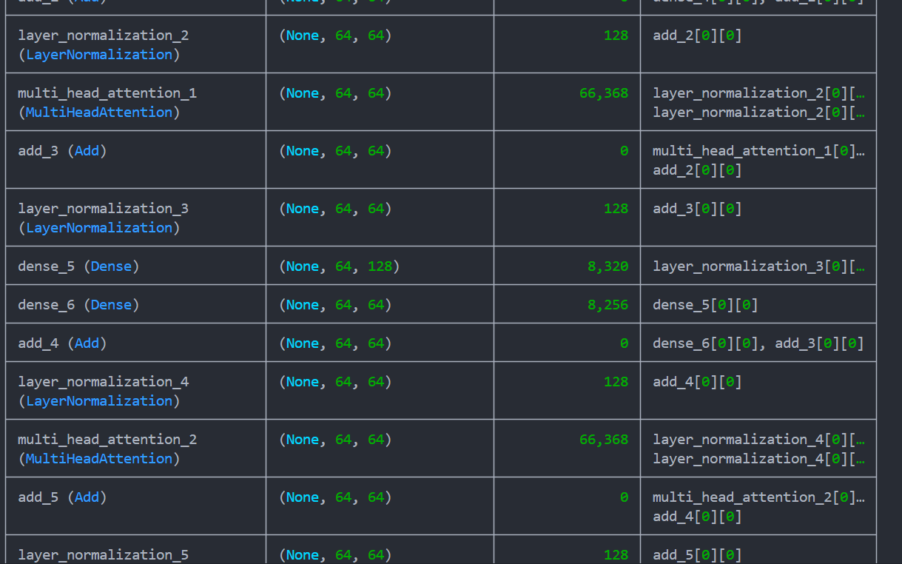

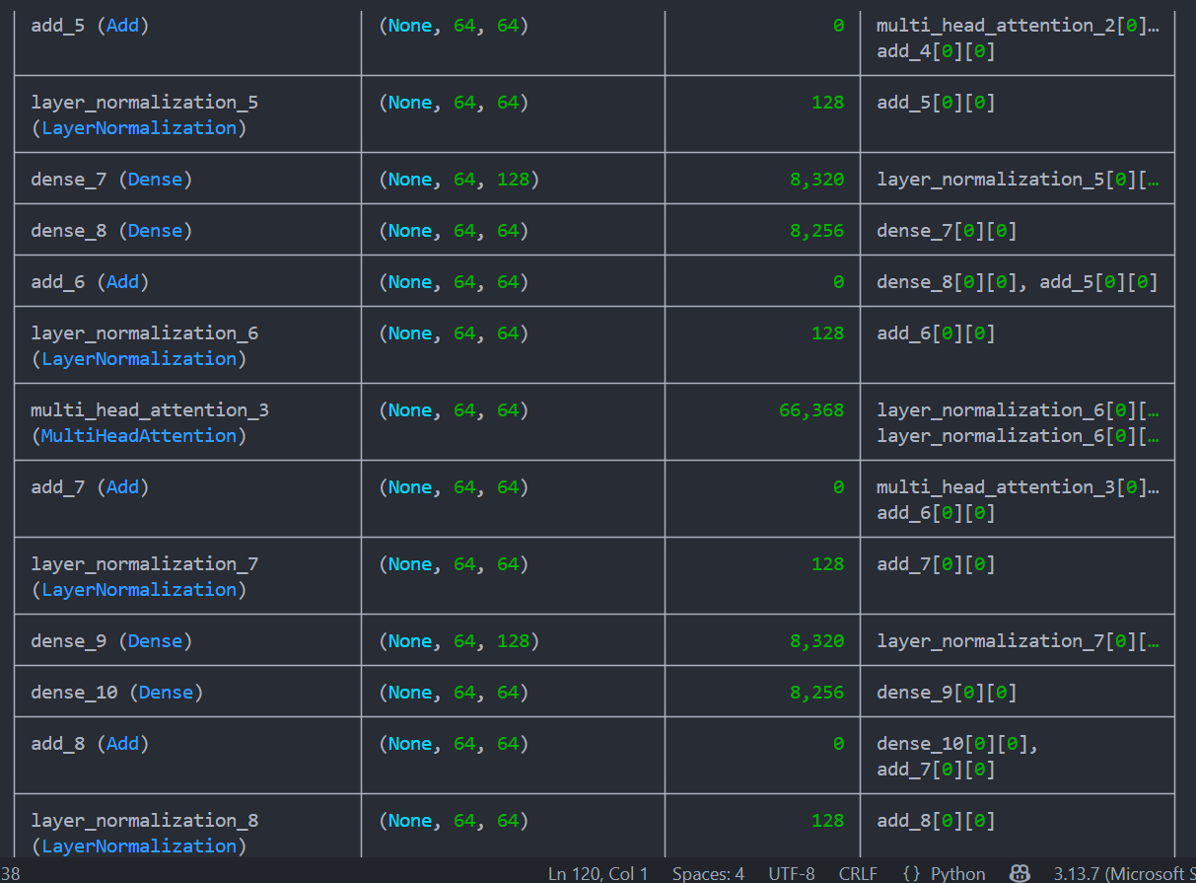

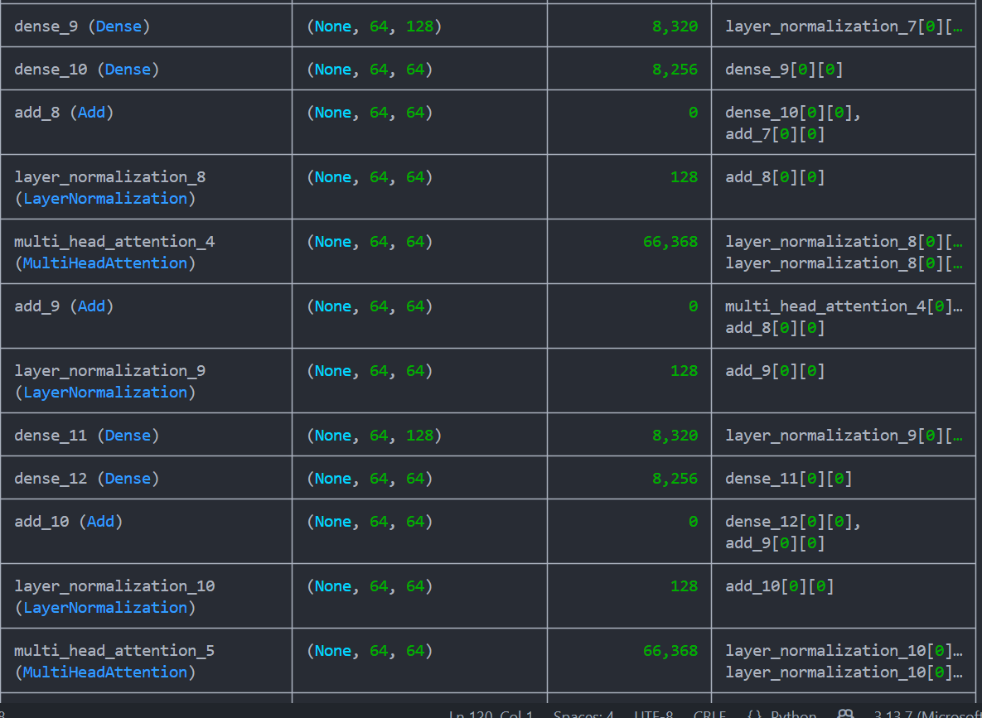

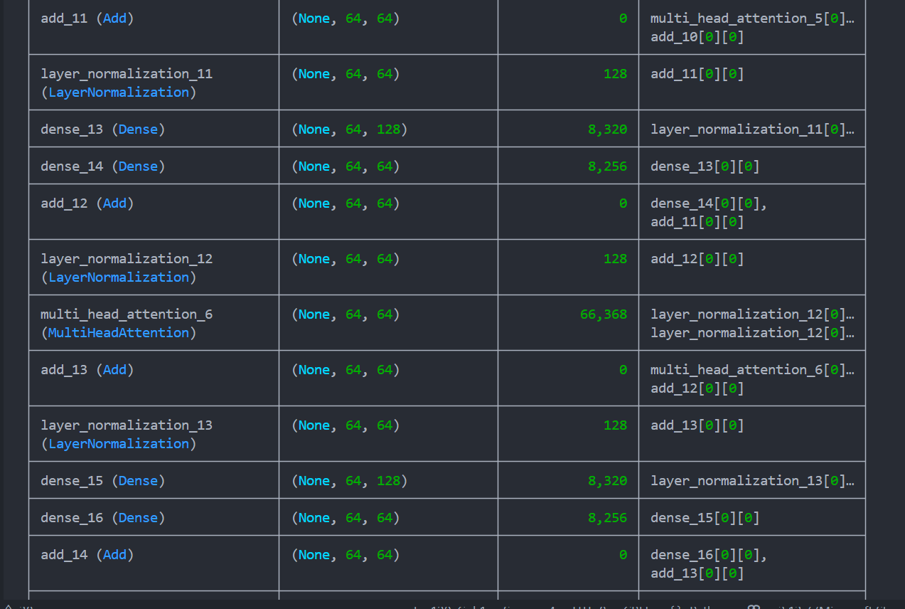

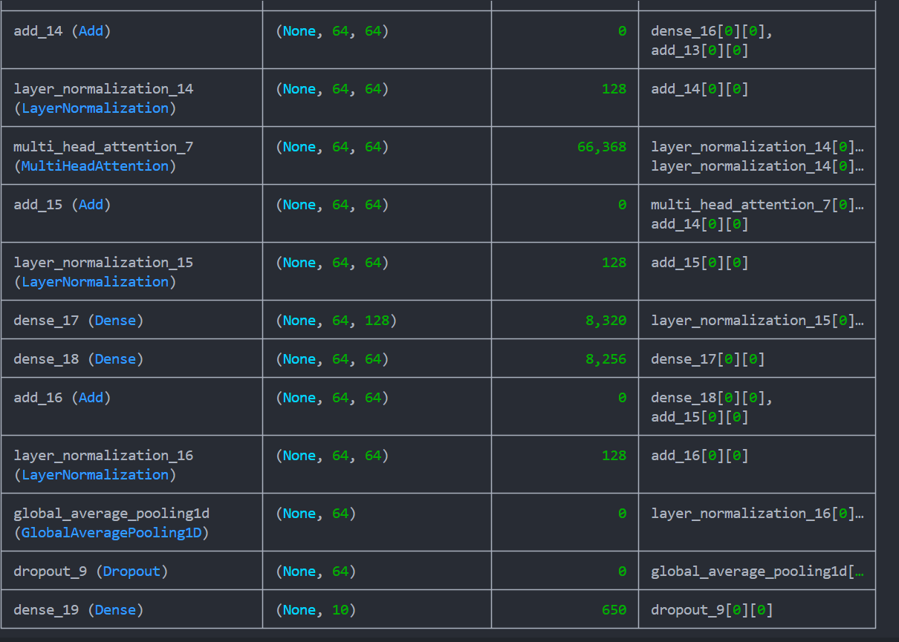

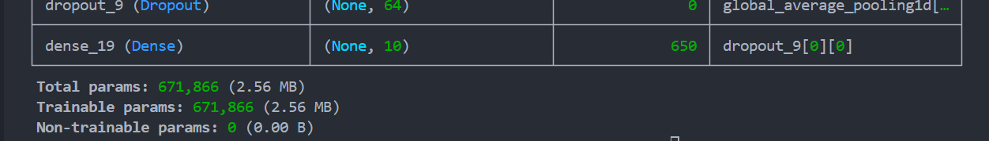

## Task 8: Train the ViT model using the CIFAR-10 dataset

* Train the ViT model using the training dataset with an appropriate number of training epochs.

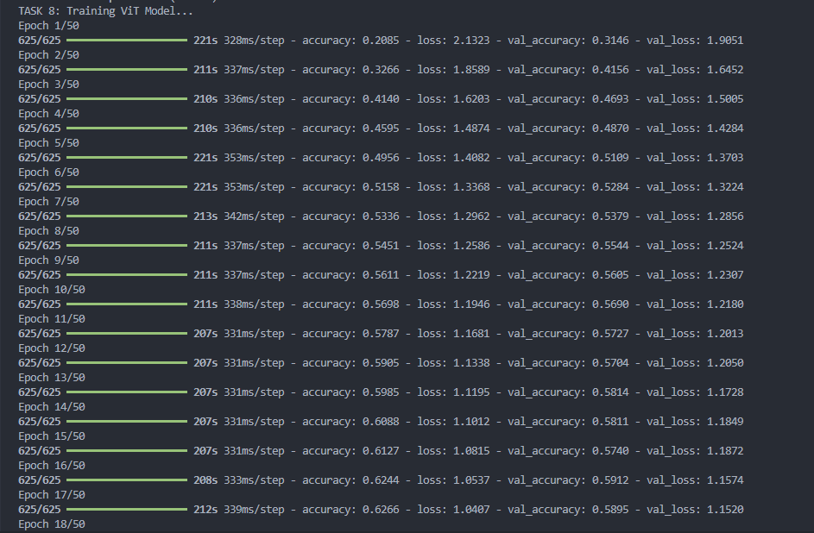

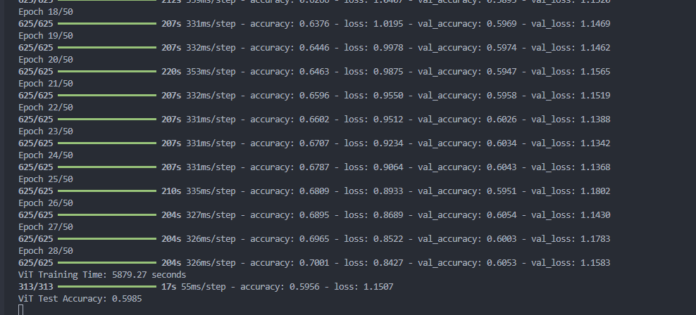

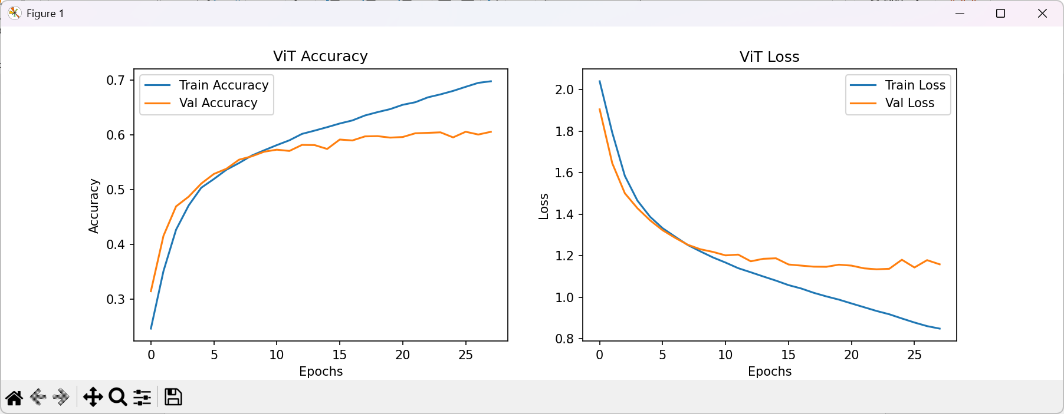

## Task 9: Display model architecture and training progress

* Display the model architecture and training progress

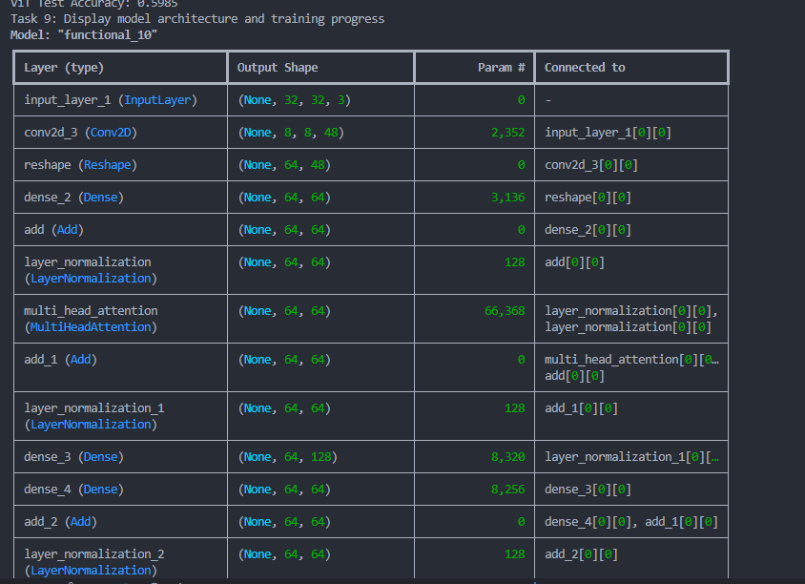

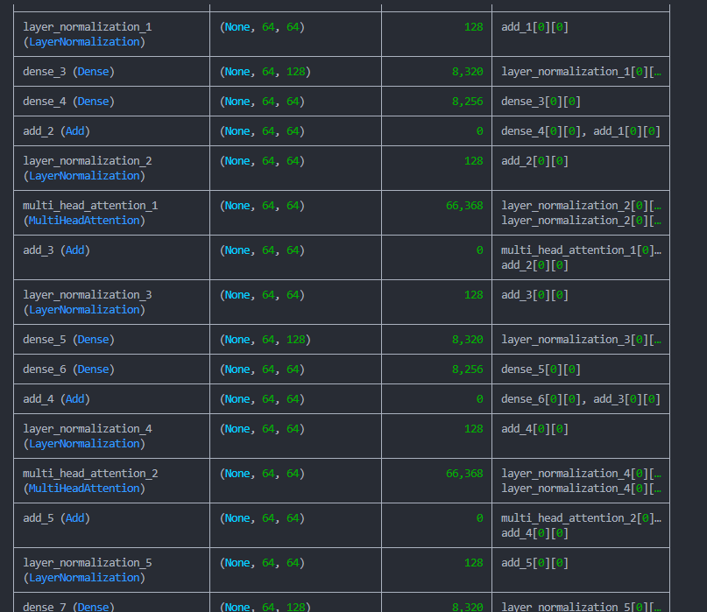

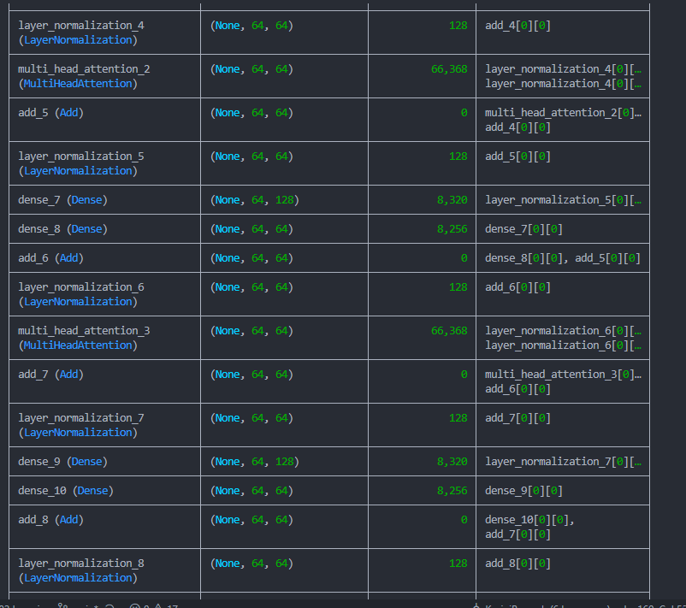

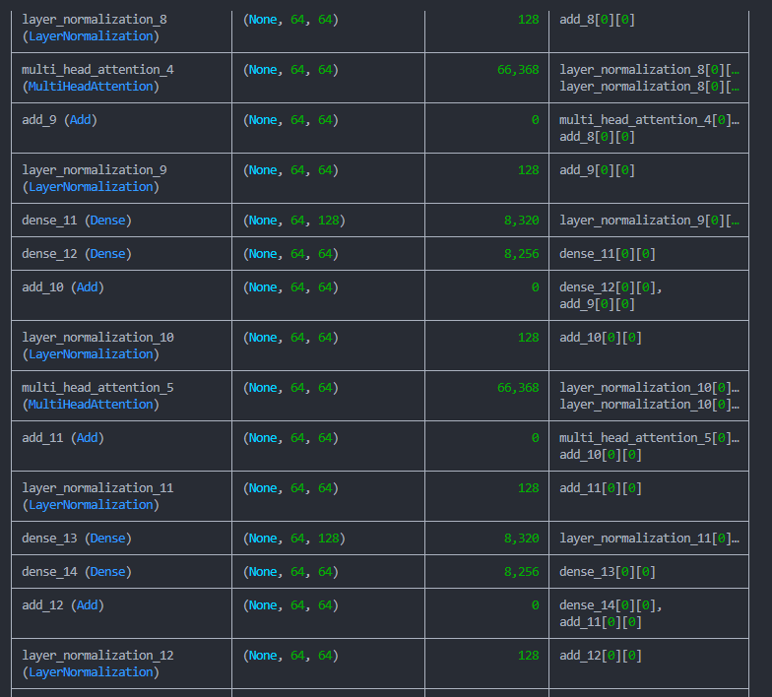

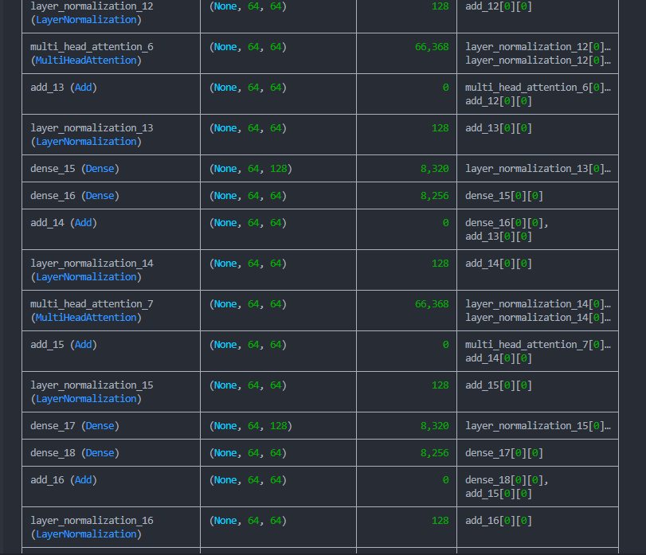

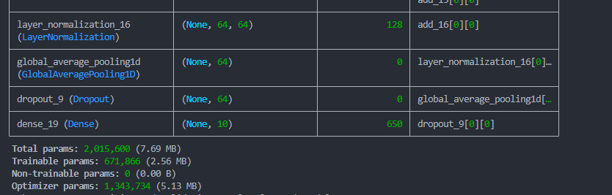

## Task 10: Compare training and validation results for each model:

* Discuss the difference in performance, training efficiency and learning dynamics or learning patterns of each model

